**ASSIGNMENT 3**

**CODE:**

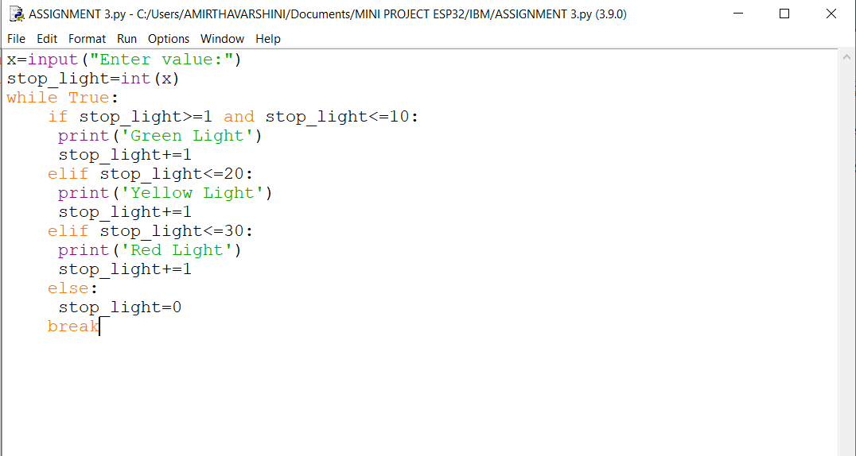

**OUTPUT:**

